

CR 05862
CRM SEA Integration for Auto Permissioning
Interface Detail Design Document

Siebel CRM to SEA Orders and SEA to CRM Order status

1) Approvals 3
2) Review List 3
3) Related Documentation 4
4) Glossary 4
5) Introduction 4
5.1 Document Context 4
5.2 Document Structure 4
5.3 Scope 4
5.4 Out of Scope 4
5.5 Assumptions 5
6) CRM SEA Integration for Auto Permissioning – New User 5
6.1 Interface Definition 5
6.1.1 Interface Purpose 5
6.1.2 Context 5
6.1.3 Functional View 6
6.1.4 Interface Characteristics 6
6.2 Interface Design : Order Request 6
6.2.1 High Level Interface Design 6
6.2.2 Data Definitions 7
6.3 Interface Design Components 8
6.3.2 CCRMOM_DequeueNValidateOrderRequest 8
6.3.3 CCRMOM_OrderRequestValidatorStub 9
6.3.4 CCRMOM_RouteToDispatcher 10
6.3.5 OM_OrderRuleManager 12
6.3.6 OM_OrderDispatcher 13
NOTE: After Fault the BPEL instance is ready for Re-initiate, Manually user/Ops team will be re-initiating after all validations done. 14
6.3.7 ATHOM_OrderSplitter 14
6.3.8 ATHOM OrderManager 15
6.3.9 ATHOM Invoker 16
6.4 Interface Design: Order Response 17
6.4.1 High Level Interface Design 17
6.5.1 ATHOM SubmitFulfilmentStatus 18
6.5.2 ATHOM_OrderFulfillmentStatus 19
6.5.3 ATHOM_OrderFulfilmentStatusStub 20
6.5.4 OM ManageOrderLineStatus 20
6.5.5 CCRMOM ProxyPropagateOrderStatus 21
6.5.6 CCRMOM PropagateOrderStatus 21
7) Developer Notes 22
➢ Code management 22
➢ Deployment Process: 22
8) Issues/Workarounds: 22
Document History
Version | Change Description | Author | Date Released
1 | CR 5862 | Sreeja

Approvals
The individuals listed below will be required to review and approve this document.
Role | Name | Signature | Date

Review List
Name | Position

Related Documentation
Ref | Title | Author | Version

Glossary

Abbreviation | Definition
CCRM | Commerce and Customer Relationship Management
EAI | Enterprise Application Integration

Introduction

Document Context
This document is one of a set of Interface Definition Documents providing the definition and High Level Design of the interfaces required for the Siebel CRM to SEA Orders inbound interface that will enable the user profile and service creation, modification, and deletion in SEA, which will ultimately be driven by the Siebel CRM system.

Document Structure
This document describes about the requirements of an interface in terms of scope, functionality and characteristics. This document focus on what the interface does from an end-to-end perspective. Also covers the design of interface and the technical integration implementation.

Scope
This document covers the interface that will support the Enterprise Application Integration (EAI) solution by providing functionality to allow:
Siebel Order Management activity will dictate the behavior in which orders are processed in SEA. The process flow described in the following section depicts the subsequent processing of a Siebel CRM Order to SEA for the creation and amendment of a user profile and the service details.

Out of Scope
- NA-

Assumptions
- Siebel CRM will be the single point of entry for order processing. EAI will send the request to SEA system only for the migrated clients only if the product Permissioning System field is “Athena” and the Product Login Type is “ATHENA to Athena.

CRM SEA Integration for Auto Permissioning – New User

Interface Definition

Interface Purpose
The purpose of this interface is to allow Siebel CRM to create and modify the users and the services in Athena.
Function | SEA
Creation of User. | Yes
Modify User (Add Service) | Yes

Context

The creation of new user process for SEA auto permissioning is initiated from Siebel CRM. This is part of an overall process which governs the user creation and modification of Thomson one services to customers. EAI will orchestrate the end to end process by invoking the creation of new user and modify services process on the SEA System through message-based event.
The orders for entitlements in SEA will be initiated from Siebel and the information for the same will flow to SEA for creation/modification/deletion of user profile and its services. SEA system requires to automatically handle user profile and services creation /deletion /modification process on receiving request from Siebel through EAI. SEA system validates the request and on successful validation the transaction requires to be created and result needs to be returned to the Siebel through EAI, whereas on validation failure the transaction will not be created. In case of synchronous response if EAI receives an error it propagates error response to Siebel and when Siebel receives an error response it sets the line item permissioning status to ‘Error’ and siebel does not proceed with the secondary entitlements.
This change request aims to solve 2 basic problems:
- CRM supports only CoreSuite billing accounts for the transactions from SEA. This limits the number of customers that can be migrated to SEA and blocks migration from CoreSuite to SAP.
- CRM orders for Thomson One products are manually permissioned in SEA. Entitlements Reps need to rekey orders from CRM into SEA and they need to manually record the result of the permissioning in CRM, including the Athena sub id for new users. As more and more customers are migrated to SEA the manual permissioning effort will increase proportionately.

Functional View

Interface Characteristics
EAI dequeues the request from MQ e_CRM_EAI_014_ORD_RQST_Q to which Siebel enqueues request message. The BPEL process, CCRMOM_DequeueNValidateOrderRequest dequeues the order data.
The messaging style used for the interface is the ‘Command Style’, where a general purpose message format is used with a standard data payload and the required functionality is specified by an ‘action code’.

Interface Design : Order Request

High Level Interface Design
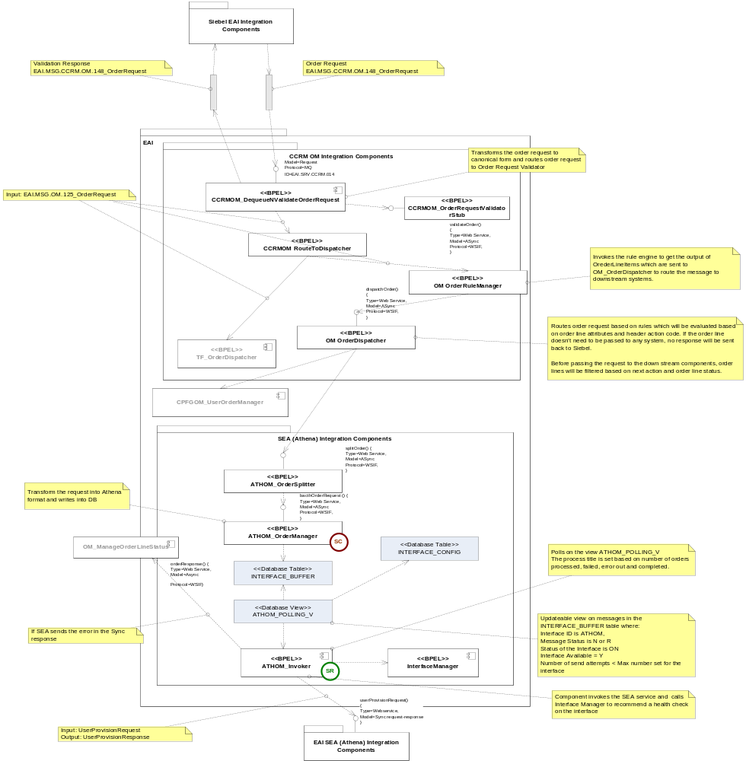
NOTE: BLUE: New BPEL Components

Data Definitions
The message specifications used in the interfaces between EAI and the external systems are defined in the API specification [6].
Latest versions of the XML schemas for the messages used in the interface are stored in the Reuters Developer Network Subversion repository (https://int.thomsonreuters.com) project called sami (https://sami.cdt.int.thomsonreuters.com). The definitions for this interface can be found in subversion at:
https://sami.cdt.int.thomsonreuters.com/svn/eai_eai/branches/6.1/design/EAI1.0/Interfaces

Interface Design Components

Module Name/Method | Module Type | Existing/New
CCRMOM_DequeueNValidateOrderRequest | BPEL | Existing
CCRMOM_OrderRequestValidatorStub | BPEL | Existing
OM OrderDispatcher | BPEL | Existing
ATHOM_OrderSplitter | BPEL | New
ATHOM OrderManager | BPEL | New
ATHOM Invoker | BPEL | New

CCRMOM_DequeueNValidateOrderRequest

- Purpose

The BPEL process dequeues the order request from the MQ and process for validating the data.

- Program Logic

AS-IS Process:
The process dequeues the message from the queue e_CRM_EAI_014_ORD_RQST_Q to which Siebel has enqueued. ‘e’ is the environment P- prod, B – blue, BL – Blue Lite, A – UAT, Q – System test, D – Support, C – Dev and NF- Non Functional.
This process transforms data into a canonical order request (EAI.MSG.CCRM.138).

TO-BE Process:
There will be a Siebel schema change with new elements for SEA integration, transformations with output schema change based on the new fields.

- DVM

No New DVM’s

- Data Mapping (Transformation)
TransRcvOrderRequestToValidateOrderRequest.xsl
TransOrderReqIVToValidationMsg.xsl
TransRouteToDispatcher.xsl

- Scope:
ValidateXML

- Exception Handling:

For all the scopes in CCRMOM_DequeueNValidateOrderRequest catch all types of exceptions and throwing the fault message.
Selection Failure:
For any Selection Failure fault exception while transformation catches the exception and throwing remote fault exception and appending the fault message to the title.
remoteFault:
For any Remote fault exception while transformation catches the exception and throwing remote fault exception and appending the fault message to the title.
runtimeFault:
For any run time fault exception while transformation catch the exception and throwing run time fault exception and appending the fault message to the title.
bindFault:
For any data binding or data validations exceptions while transformation catch the exception and throwing remote fault exception and appending the fault message to the title.

NOTE: After Fault the BPEL instance is ready for Re-initiate, Manually user/Ops team will be re-initiating after all validations done.

- Input/output Schemas:

EAI.MSG.CCRM.138.xsd
EAI.MSG.CCRM.148.xsd

- Partner links

DequeueOrderRequest.wsdl
UpdateCSValidationMessage.wsdl
CCRMOM_OrderRequestValidatorStub

CCRMOM_OrderRequestValidatorStub

- Purpose
Validates EAI.MSG.CCRM.138 schema.

- Program Logic

AS-IS Process:

There is no actual logic within this component it just accepts the input data and returns it in a response.

TO-BE Process:
The SIEBEL schemas will be defined with additional fields.
- DVM
-NONE-

- Data Mapping (Transformation)
NA

- Input/output Schemas:
EAI.MSG.CCRM.138.xsd

- Partner links
NA

CCRMOM_RouteToDispatcher

- Purpose

The BPEL process does the DB operations ( insert and select) on the Asset_Cache and Order_Cache tables for the order request received from the CCRMOM_DequeueNValidateOrderRequest and routes the message OM_OrderRuleManger and TF_OrderDispatcher.

- Program Logic

AS-IS Process:
This process writes the assetIntegrationId, permissioning system, billing platform and pli into asset cache table for the initial creation of the order. For modify request it looks up the permissioning system and billing platform from asset cache table for the assetIntegrationId and sends to the down stream system this is implemented to avoid the x002 error as the product attributes are changed in Siebel.

All the order detail is stored in Order_cache table by using DB adapter on receipt of order request. Before calling DB adapter certain condition are checked. The default value for the csaction field in the table is set to ‘SAMEORDER’, if the install to and bill to subscribers are same and the permissioning and billing system are SPM and IRAS then the csaction is set as ‘SAMEORDER’ else ‘SPLITORDER’.

As part of the transformation the date format is to be transformed to ‘YYYY-MM-DD’ and date time format to ‘YYYY-MM-DDTHH24:MI:SS’.
Siebel sends the requests with date in the format ‘MM/DD/YYYY’.
- TO-BE Process:
There will be a Siebel schema change with new elements for SEA integration, transformations with output schema change based on the new fields.

- DVM

No New DVM’s

- Data Mapping (Transformation)

TransExtendOrderReqToOrderReqValidator.xsl
TransInsertIntoAssetCacheTable.xsl
TransLookupAssetCacheTable.xsl
TransOrderRequestToDispatcher.xsl
TransOrderRequestToOrderCacheDBAdapter.xsl
TransOrderRequestToTFOrderDispatcher.xsl

- Scope:
DB lookup

- Exception Handling:

For all the scopes in CCRMOM_RouteToDispatcher catch all types of exceptions and throwing the fault message.
Selection Failure:
For any Selection Failure fault exception while transformation catches the exception and throwing remote fault exception and appending the fault message to the title.
remoteFault:
For any Remote fault exception while transformation catches the exception and throwing remote fault exception and appending the fault message to the title.
runtimeFault:
For any run time fault exception while transformation catch the exception and throwing run time fault exception and appending the fault message to the title.
bindFault:
For any data binding or data validations exceptions while transformation catch the exception and throwing remote fault exception and appending the fault message to the title.

NOTE: After Fault the BPEL instance is ready for Re-initiate, Manually user/Ops team will be re-initiating after all validations done.

- Input/output Schemas:

EAI.MSG.CCRM.138.xsd
EAI.MSG.CCRM.148.xsd

- Partner links

DBAdapterOutboundHeader.wsdl
AssetCacheDBAdapter.wsdl
OrderCacheDBAdapter.wsdl
OM_OrderRuleManger and TF_OrderDispatcher

OM_OrderRuleManager

- Purpose
Receives order request, invokes rule engine to get the outcome of the rules for OLIs and routes the message to OM_OrderDispatcher.This component acts as a bridge between the Siebel and downstream components within EAI. Orchestrates the order based on the order line attributes.
- Program Logic

AS-IS Process:

There is no change in the as is logic, there will be change in the rules to accommodate the migration check for the existing rules for CoreSuite-billed line items.

TO-BE Process:
The SIEBEL schemas will be defined with additional fields.
The process receives Order Request (EAI.MSG.OM.125_OrderRequest.xsd) and pass each order line attributes to the decision service to decide the actions based on the business rules defined in the rules repository, next action is derived based on the outcome of the rules.
- DVM
-NONE-

- Data Mapping (Transformation)

TransBPELVarToFacts.xsl
TransExtendedOrderRequestToRuleFacts.xsl
TransExtendedToOrderRequest.xsl
TransFactsToBPELVar.xsl
TransFactsToRuleService.xsl
TransOrderRequestToExtendedOrderRequest.xsl
TransRuleFactsToExtendedOrderRequest.xsl
TransRuleServiceToFacts.xsl

- Input/output Schemas:
EAI.MSG.OM.125_OrderRequest.xsd
EAI.MSG.OM.193_ExtendedOrderRequest.xsd
EAI.MSG.OM.259_OrderRequest.xsd

- Partner links
DeriveNextAction.wsdl
OM_OrderDispatcher

- Exception Handling:

The process catch the below exceptions.

remoteFault:
For any Remote fault exception while transformation in Parallel flows catch the exception and throwing remote fault exception and appending the fault message to the title.
runtimeFault:
For any run time fault exception while transformation in Parallel flows catch the exception and throwing run time fault exception and appending the fault message to the title.
bindFault:
For any data binding or data validations exceptions while transformation in Parallel flows catch the exception and throwing remote fault exception and appending the fault message to the title.
NOTE: After Fault the BPEL instance is ready for Re-initiate, Manually user/Ops team will be re-initiating after all validations done.

OM_OrderDispatcher

- Purpose
Receives order request and initiates call to the downstream components based on the outcome of the rules that are defined in the rules engine.
- Program Logic

AS-IS Process:

Logic is implemented to route the messages to SEA when Permissioning System is ‘Athena’.

TO-BE Process:
The SIEBEL schemas will be defined with additional fields.
The process receives Order Request (EAI.MSG.OM.125_OrderRequest.xsd).
For the new user, the process initiates 2 flows if the billing system is ‘IRAS’ and Perm system is ‘Athena’. An ATHOM_OrderSplitter component is invoked to propagate the order for entitlement in Athena system and also invokes OM_OrderSplitter component which sends the request to Coresuite for billing. It does this by checking for the presence of a note on the account field of type ‘SEA Account’. If the customer has been migrated to SEA then ATHOM_OrderSplitter is invoked to send the line items to SEA for automatic permissioning otherwise the existing functionality i.e. will propagating the request to CS for billing will be called.

- DVM
-NONE-

- Data Mapping (Transformation)
TransFilterSEAOrder.xsl

- Input/output Schemas:
EAI.MSG.OM.125_OrderRequest.xsd
EAI.MSG.OM.193_ExtendedOrderRequest.xsd
EAI.MSG.OM.259_OrderRequest.xsd

- Partner links
ATHOM_OrderSplitter

- Exception Handling:

The process catch the below exceptions.

remoteFault:
For any Remote fault exception while transformation in Parallel flows catch the exception and throwing remote fault exception and appending the fault message to the title.
runtimeFault:
For any run time fault exception while transformation in Parallel flows catch the exception and throwing run time fault exception and appending the fault message to the title.
bindFault:
For any data binding or data validations exceptions while transformation in Parallel flows catch the exception and throwing remote fault exception and appending the fault message to the title.

NOTE: After Fault the BPEL instance is ready for Re-initiate, Manually user/Ops team will be re-initiating after all validations done.

ATHOM_OrderSplitter

- Purpose

This is an asynchronous process which splits the order based on subscribers and calls ATHOM_OrderManger.

- Program Logic:

- The process receives order request (EAI.MSG.ATH.OM.300_OrderRequest.xsd) sorts and group based on the subscriber and sends a request by invoking ATHOM_OrderManger for each subscriber. For each subscriber a new instance of ATH_OrderManager is created.

- Data Mapping (Transformations)

- DVM:
- Shall be defined after the schemas are shared --

- Partner links:
ATHOM_OrderManger

- Exception Handling:

For all the scopes in ATHOM_OrderSplitter catch all types of exceptions and throws the fault message.
remoteFault:
For any Remote fault exception while transformation in Parallel flows catch the exception and throwing remote fault exception and appending the fault message to the title.
runtimeFault:
For any run time fault exception while transformation in Parallel flows catch the exception and throwing run time fault exception and appending the fault message to the title.
bindFault:
For any data binding or data validations exceptions while transformation in Parallel flows catch the exception and throwing remote fault exception and appending the fault message to the title.
NOTE: After Fault the BPEL instance is ready for Re-initiate, Manually user/Ops team will be re- initiating after all validations done.

ATHOM OrderManager

- Purpose

This is an asynchronous process which splits the request based on the user and its services and transforms the request into Athena format and inserts the data into interface_bufer table.
- Program Logic:

- The process receives order request (EAI.MSG.ATH.OM.301) and groups it based on the users and under each users it groups the services for that user.
- Transforms the request into Athena format which is tree structure and inserts into interface buffer table. Logical data model required by SEA is quite different to the logical model published by Siebel.
- Data Mapping (Transformations)

- DVM:
- Shall be defined after the schemas are shared --

- Partner links:

- Exception Handling:

For all the scopes in ATHOM OrderManager catch all types exceptions and throwing the fault message.
remoteFault:
For any Remote fault exception while transformation in Parallel flows catch the exception and throwing remote fault exception and appending the fault message to the title.
runtimeFault:
For any run time fault exception while transformation in Parallel flows catch the exception and throwing run time fault exception and appending the fault message to the title.
bindFault:
For any data binding or data validations exceptions while transformation in Parallel flows catch the exception and throwing remote fault exception and appending the fault message to the title.
NOTE: After Fault the BPEL instance is ready for Re-initiate, Manually user/Ops team will be re-initiating after all validations done.

ATHOM Invoker

- Purpose

This process polls the data from the view and sends the request to SEA, SEA sends the synchronous response and on error sets the line item permissioning status to ‘Error’ and propagates the message to Siebel CRM.
- Program Logic:

The ATHOM Invoker
The process which reads data from the table inserts the same data into the interface buffer table.
ATHOM_Invoker polls data from ATHOM_Polling_V (View Created for Interface buffer) for all the messages with the interface_id=’ATHOM’, state set as ‘N’ or ‘R’ for every 10 seconds.
It then checks for any running instances which would affect the initiation of this instance. If found any, the process waits for the completion of the same and in the other case the process in initiated.
The above process follows the update call to the interface buffer table. During which the state is changed to ‘C’ upon completion of process.

- Exception Handling:

For All the scopes in ATHOM Invoker catch all types exceptions and throwing the fault message.
remoteFault:
For any Remote fault exception while transformation in Parallel flows catch the exception and throwing remote fault exception and appending the fault message to the title.
runtimeFault:
For any run time fault exception while transformation in Parallel flows catch the exception and throwing run time fault exception and appending the fault message to the title.
bindFault:
For any data binding or data validations exceptions while transformation in Parallel flows catch the exception and throwing remote fault exception and appending the fault message to the title.
NOTE: After Fault the BPEL instance is ready for Re-initiate, Manually user/Ops team will be re-initiating after all validations done.

- Data Mapping (Transformations)

- Partner links:
ATHAOM_POLLING (DB Adapter)

- Database:
Interface_buffer,
Interface_Config

Interface Design: Order Response

High Level Interface Design

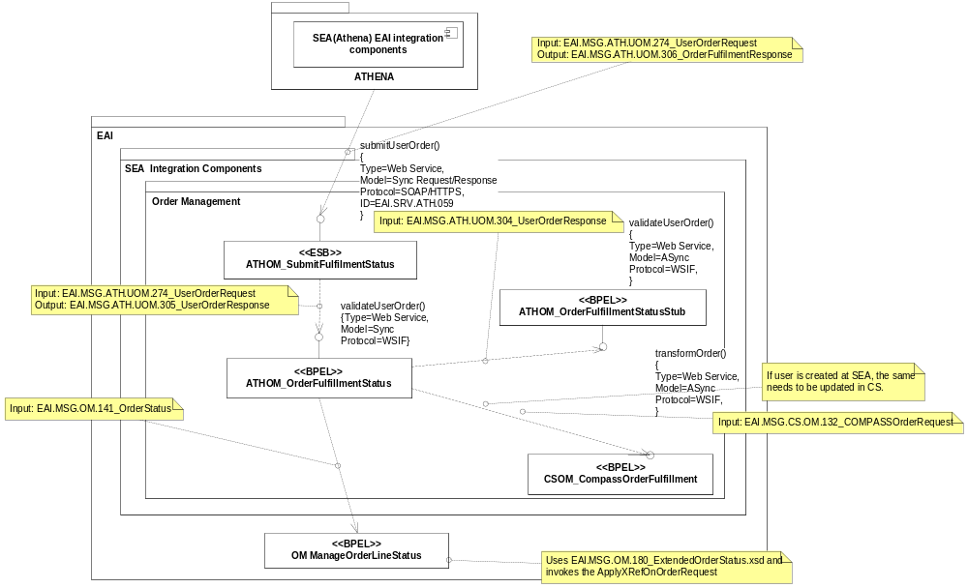
NOTE: BLUE: New flow to be added in the existing ATH-EAI-Siebel flow
6.5 Interface Design Components: Order Response

Module Name/Method | Module Type | Existing/New
ATHOM_SubmitFulfilmentStatus | ESB | New
ATHOM_OrderFulfillmentStatus | BPEL | New
ATHOM_OrderFulfillmentStatusStub | BPEL | New
OM ManageOrderLineStatus | BPEL | Existing
CCRMOM ProxyPropagateOrderStatus | BPEL | Existing
CCRMOM PropagateOrderStatus | BPEL | Existing

ATHOM SubmitFulfilmentStatus

- Purpose

- SEA submits the asynchronous response for auto permission by invoking the service which is exposed by EAI. This interface is a synchronous web service invoked using SOAP over HTTPS. The messaging style used for the ATHOM_SubmitFulfilmentStatus interface is the ‘Command Style’, where a general purpose message format is used with a standard data payload and the required functionality is specified by an ‘action code’.
- Program Logic:
This process receives the message - EAI.MSG.ATH.UOM.274_UserOrderRequest from SEA and sends the response to ATHOM_OrderFulfillmentStatus.
Once ATHOM_OrderFulfillmentStatus sends the Sync response, it will route the message EAI.MSG.ATH.UOM.306_OrderFulfilmentResponse - to SEA.

- Exception Handling:
NA
- Data Mapping (Transformations)
TransOrderFulfilmentStatusToFulfilmentValidate.xsl
TransValidationResponseToFulfilmentResponse.xsl

- Partner links:
ATHOM_SubmitOrderFulfilmentStatus.wsdl
- Database:
NA

ATHOM_OrderFulfillmentStatus

- Purpose

- This process validates the request and responds back to SEA with the status. On successful validation the process invokes om_manageorderline status.
- Program Logic:

This process receives the message from ATHOM_SubmitFulfilmentStatus and sends the message to ATHOM_OrderFulfillmentStatusStub to validate the response received from SEA.

Once validation is done, it will route the message to OM_ManageOrderLineStatus in following cases:
- When the request status is ‘COMPLETION’ in the response received from SEA
- When the status is ‘FAILURE’ in the response received from SEA

If user is created at SEA, response should also be sent to CS to update the user details at CS.
- Exception Handling:
NA
- Data Mapping (Transformations)
TransATHENARespToCS.xsl
TransNewUserRequestToCompassOrder.xsl
TransOrderFulFillmentStatusToOrderFulFillmentStub.xsl
TransOrderFulfillmentToNewUserRequest.xsl
TransOrderFulfillReqToOrderFulfillRes.xsl
TransOrderFulfillStatusToManageOrderLineStatus.xsl
TransOrderfulfillStatusToOrderCacheCollection.xsl
TransRcvOrderStatusToReplyOrderStatus.xsl
TransSetNullData.xsl

- Partner links:
OM_ManageOrderLineStatus
CSOM_CompassOrderFulfilment
ATHOM_OrderFulfilmentStatusStub

- Database:
NA

ATHOM_OrderFulfilmentStatusStub
- Purpose

There is no actual logic within this component it just accepts the input data and returns it in a response.
- Program Logic:
This process receives the response from ATHOM_OrderFulfilmentStatus and validates the same against the XSD.
- Exception Handling:
NA
- Data Mapping (Transformations)
NA
- Partner links:
NA
- Database:
NA

OM ManageOrderLineStatus
- Purpose

- This process processes the order status based on the status rules defined in the rules engine.
- Program Logic:
AS-IS Process:

The existing process remains same and no change in the existing logic

TO-BE Process:
The EAI canonical schemas with additional fields for the response

- Exception Handling:
NA
- Data Mapping (Transformations)

- Partner links:

- Database:
NA

CCRMOM ProxyPropagateOrderStatus
- Purpose

- The service transforms and routes the order status.
- Program Logic:
AS-IS Process:

There is no change to the existing logic.

TO-BE Process:
The EAI canonical schemas with additional fields for the response.

- Exception Handling:
NA
- Data Mapping (Transformations)

- Partner links:

- Database:
NA

CCRMOM PropagateOrderStatus
- Purpose
- The service transforms and routes the order status to Siebel integration components by enqueuing Message to Siebel MQ
- Program Logic:
AS-IS Process:

There is no change in the logic.
TO-BE Process:
Additional fields in the schema.
- Exception Handling:
For all the scopes in the process catch all types of exceptions and throwing the fault message.
remoteFault:
For any Remote fault exception while transformation in Parallel flows catch the exception and throwing remote fault exception and appending the fault message to the title.
runtimeFault:
For any run time fault exception while transformation in Parallel flows catch the exception and throwing run time fault exception and appending the fault message to the title.
bindFault:
For any data binding or data validations exceptions while transformation in Parallel flows catch the exception and throwing remote fault exception and appending the fault message to the title.
NOTE: After Fault the BPEL instance is ready for Re-initiate, Manually user/Ops team will be re-initiating after all validations done.

- Data Mapping (Transformations)

- Partner links:

- Database:
NA

Developer Notes

Code management
For Code management and usage of subversion refer the document.

Deployment Process:
The deployment process for BPEL, ESB or web services components and as well as for any other deployments like DB Scripts, Business rules configurations: refer EAI- Build and Deployment Process.doc in https://sami-crm6-eai.reutersdev.net/svn/sami-crm6-eai/trunk/dev/EAI-CRM61/R2releases/BuildDocs folder in SVN.

Issues/Workarounds:

S.No | Summary | Status | Assigned to | Solution
1 | Siebel CRM Schemas | Open | CRM team
2 | SEA Schemas | Open | SEA

